Anthony Lucchese
Prof. Kaufmann
Due 2 February 2022
Web Programming

Q1. What are the advantages of packet switching in comparison to circuit switching?

Circuit Switching is when two users establish a connection, physically connecting the sender and the receiver. The weakness of this is that during the whole duration of the connection, the connection itself must be maintained. This is similar to how TCP protocol works, by establishing a two-way connection, with a handshake, then sending packets back and forth. When Circuit Switching is used, it is difficult to have multiple conversations simultaneously and also requires more bandwidth on down time between messages being sent. An alternative to this was called packet switching. Kind of like TCP has its UDP connection, circuit switching has its packet switching. Packet-switched networks do not require a continuous connection. Instead it splits the message into smaller chunks into packets and routes them to the appropriate place based on the destination address. These packets can take different routes to the destination. This method is more robust and a better use than circuit switching because there are many failsafe and a more efficient use of network resources

Q2. What is an intranet
Intranets are internal networks using internet protocols that are local to an organization or business. Intranet resources are often private, where only the employer or the owner of the network can access the resources. These intranets are mostly private and are typically protected from unauthorized external access via security features such as firewalls or private IP ranges. Depending on a company they can acess certain internal features that the company might give out. For example, if you are Google and have a cloud processing application that outside user can pay to use, that would be considered part of googles intranet, but only certain parts of that intranet can be accessed by that user. Ex. I ask google to scan Twitter.com for a certain keyword “baseball” and it returns a JSON file full of links. This would use Google’s computing power, in turn its own intranet, but only certain parts of that intranet are accessible because that is the only thing the user can use. Another thing Is that an intranet uses its own IP addresses starting with 196.168.x.x, indicating that it si a local IP address, and not a public IP address.

Q3. What is a dynamic web page? How does it differ from a static page?
A dynamic web page is a more complicated website, interacting with databases, interface with existing enterprise systems, communicate with financial institutions, and output HTML that would be viewable by the user. These web pages are being created at run-time, instead of being stored in a server as an HTML file. Utilizing dynamic web pages came more and more complicated web sites, that can play games, show animations and youtube videos etc, act as actual programs, called web applications and much more.

Q4. How many distinct domains can be hosted at a single IP address?
Theoretically, an infinite number of domains can be hosted at a single IP address. The only issue is being able to handle infinite domains. To access a domain, you need to utilize a DNS, domain name server converts the URL to an IP. All URLs are actually just IPs in disguise. To test this, you can just type in [ ping google.com ] in Command Prompt or terminal to send packets to the address 142.251.32.110 which is Google’s IP when pinging them. All DNS servers just redirect a link to an IP, similar to an HREF, you can have whatever text as the preface of an HREF, but it’s always going to send to the same link (if the link is the same of course).

Q5. How can browser extensions help and hinder web developers?
Browser extensions are revolutionary for web developers and users alike. Personally, I have uBlock Origin installed on Firefox, which blocks ads from all websites I enter. This is one-way extensions hinder web developers, it can inhibit them from getting paid from the ads on their website. Other extensions can also provide a debugger that is more developer friendly than the debugger google or chromium or Firefox provides. Other extensions could block trackers that are third party sending information from the current website to another website / company for targeted advertising as well, which I believe is good. Hate the System!

VPN:
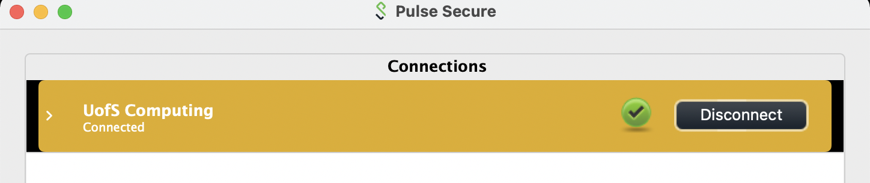
Visual Studio Code:
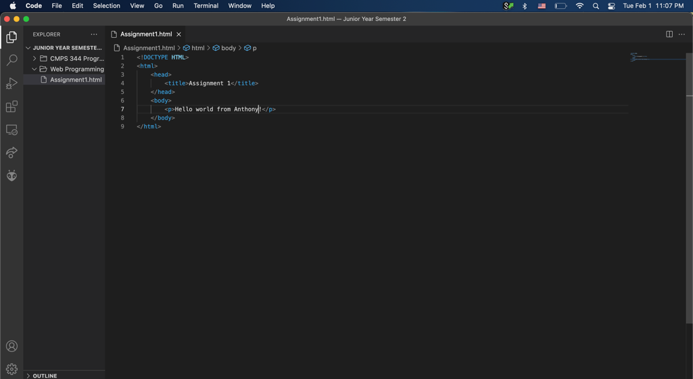
FileZilla client:
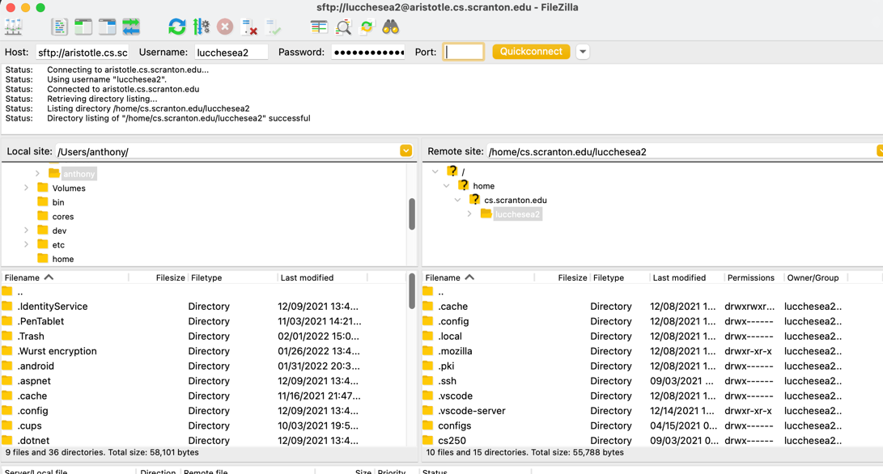

HTML website:
